Eventi
An Event Sharing Website

Submitted to:

Prof. Ma. Rowena C. Solamo
Faculty Member
Department of Computer Science
College of Engineering
University of the Philippines, Diliman

Submitted by:
Dimaano, Aaron Diego I.
Lopez, Matthew S.
Torres, Jacob Angelo V.

In partial fulfillment of Academic Requirements
for the course
CS 191 Software Engineering I
of the
1st Semester, AY 2014-2015

Unique Reference:
The documents are stored in this repository: https://github.com/Tom-2013-06417/CS191-192_Event_Sharing

Document Purpose:
The purpose of this document is to elaborate on the conception, processes, and features of NEYUM as a website. Through the included context diagram, this document also aims to show how the users are expected to interact with the software.

Target Audience:
The students of the University of the Philippines, Diliman are the website’s main target audience. However, the software can also be extended to suit other university personnel, even reach people outside the university.

Revision Control:

Revision Date | Person Responsible | Version Number | Modification
08/26/2015 | Diego Dimaano  Matthew Lopez  Jacob Torres | 1.0 | Initial Document

Project Title: Eventi

Description:
Eventi is a website that aims to centralize all general events within the university and therefore providing a platform for those who seek publicity for their event as well as for those who want a single go-to site containing for everything they need to know about the events in UP.

Context Diagram:

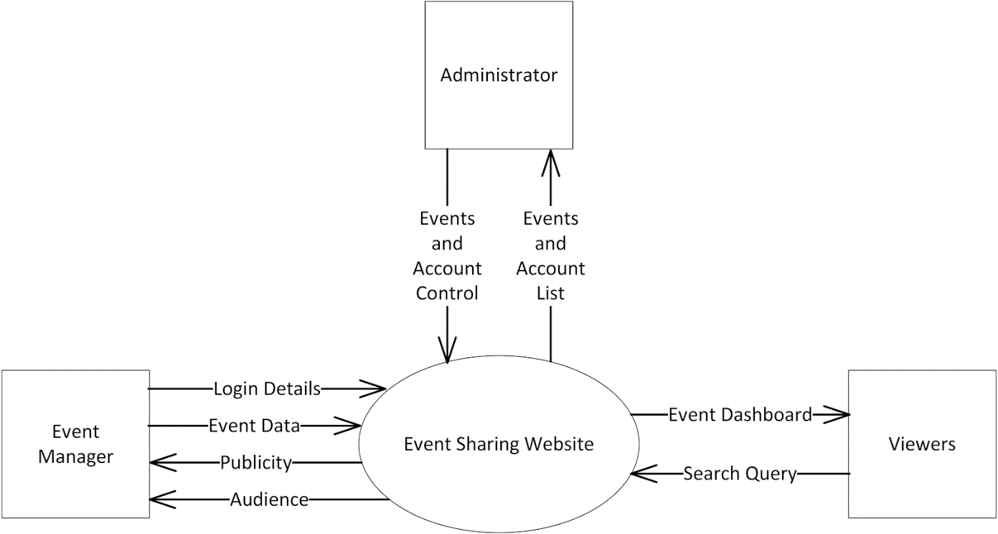

Entities:
- Viewer
  - is a person that entered the site for the purpose of looking up event details
  - interacts with the dashboard when they use the site
  - has a login option that provides additional functionalities such as saving to a calendar, subscribing to certain users, and following uploads under certain tags
  - reports to the administrator whenever they encounter wrong, malicious, or illegal content on the site
- Event Manager
  - is a person (usually an org representative, an event host, a typical student, etc.) who uses the site to upload or manage the events to be publicized
  - interacts with the interface by adding events and posting updates to the site’s database
  - provides login credentials to upload and edit event details
- Administrator
  - manages the safety and credibility of the site and its events
  - warns, suspends, or terminates accounts that post malicious or illegal content on the site

Major Input:

Events
- Event details are to be inputted by registered event managers to be included to the site’s public dashboard
- Required Event Details:
  - Event Name
  - Event Description
  - Tags
  - Venue
  - Date/Duration
  - Publicity Material Image/s
  - Contact Details
  - Event Organizers
  - Event Price (if any)
- Additional Event Details:
  - Event Capacity
  - Attire
  - Things to Bring
  - Miscellaneous Info
  - Target Audience
  - RSVP Form Link
  - Link to main site/page

Major Outputs:

Event Dashboard
- Displays the events of the user account currently in the site’s database
- Prioritizes events that are immediate, trending, or promoted
- Suggests events based on recent search information
- Provides an interface to view all recently posted events
- Contains functionalities for searching events using keywords and tags
- Can be customized by logged-in users through tags and subscription to other users and events

User Calendar and Unified Timeline
- Displays the events the user subscribed to in calendar or timeline form
- Stores a viewer’s past / bookmarked events
- Reminds the user of upcoming events

Major Functionalities:
- Event Management Features
  - upload new events
  - edit posted events while notifying subscribers
- Event Dashboard
  - display events sorted either by popularity, relevance, or time of post upload
  - can be customized by logged in users to manage the events they see on the dashboard
- Account Information Management
  - edit account information
  - view calendar, timeline, and subscribed events
- Events Promotion
  - pay the site money to make sure your pubmat gets noticed more often

